# Brainstorm

**TIP**

You can select a sticky note and hit the pencil [switch to sketch] icon to start drawing!

## Before you collaborate

### A little bit of preparation goes a long way with this session. Here’s what you need to do to get going.

#### 10 minutes

## 1

**Define your problem statement**

### What problem are you trying to solve? Frame your problem as a How Might We statement. This will be the focus of your brainstorm.

#### 5 minutes

**2**

## Brainstorm

### Write down any ideas that come to mind that address your problem statement.

#### 10 minutes

## 3

**Group ideas**

### Take turns sharing your ideas while clustering similar or related notes as you go. In the last 10 minutes, give each cluster a sentence-like label. If a cluster is bigger than six sticky notes, try and see if you and break it up into smaller sub-groups.

#### 20 minutes

## 4

**Prioritize**

### Your team should all be on the same page about what's important moving forward. Place your ideas on this grid to determine which ideas are important and which are feasible.

#### 20 minutes

## After you collaborate

You can export the mural as an image or pdf to share with members of your company who might find it helpful.

# & idea prioritization

**PROBLEM**

**In some industrial plants there are some areas which are to be monitor time to time by using beacon scanner**

Every person working in those areas will be given smart werable devices

In individual firms in which flammable substances are used in environments

Use this template in your own brainstorming sessions so your team can unleash their imagination and start shaping concepts even if you're not sitting in the same room.

**10 minutes** to prepare

**1 hour** to collaborate

**2-8 people** recommended

##### Team gathering

Define who should participate in the session and send an invite. Share relevant information or pre-work ahead.

##### Set the goal

Think about the problem you'll be focusing on solving in the brainstorming session.

##### Learn how to use the facilitation tools

Use the Facilitation Superpowers to run a happy and productive session.

##### [Open article](https://support.mural.co/en/articles/2113740-facilitation-superpowers)

##### Sathya. P

Remote monitoring of machines

1.process areas 2.storage locations

1.physical hazard

2.chemical hazard

3. Ergonomic hazard

4.biological 5.safety

*well planned design and layout

*chemical data sheets

##### Ramya.R

**TIP**

Add customizable tags to sticky notes to make it easier to find, browse, organize, and categorize important ideas as themes within your mural.

Smart wearable device will be acting as beacon scanners

1. Resistance temperature detector
2. Thrmocouples 3.Infrared pyrometers

1.Freezing type (20<0)

2.micro cold type(5)

3.Normal temperature

4.Warm type(20)

Efficient energy trading

##### preethiya .s

Industrial accidents are as old as industry itself and so are preventive measures

FIRE is a oxidation reduction reaction

class A such as paper, wood, textile fibers

Explosion and an fire are two of the major constituents of the mishaps

class B such as gasoline, thinners, oil based paints, greases

## sneha .k

A chemical hazard is a substance that has the potential to cause harm to life or health

1.Monitoring 2.Maintance 3.Redundancy

4.Aging plants

ABB smart sensors designed for rotating equipementin hazardous atmospheres

Earlier days monitoring of industrial situations takes place with help of CCTV cameras

Now a days automation is a major part in indusry

FIRE which results in the production of heat and generally visible light

Employers should monitor and record the exposure of workers to hazardous chemical to ensure their safety and health

Hazard is anything with potential for producing an accident

To promote the implementation of more efficent preventive measures

common industrial temperature measurement devices

Techniques for this risk assessment may include: method of work and work pattern, simple qualitative tests etc......

The beacon will be broadcasting the temperature of that particular area

Depending upon the environment these can be termed near misses in the safety officers statistics

DSEAR as

any place in which an explosive atmosphere

Beverage level monitoring system

Reduced equipment break down

## Quick add-ons

##### Share the mural

**Share a view link** to the mural with stakeholders to keep them in the loop about the outcomes of the session.

##### Export the mural

Export a copy of the mural as a PNG or PDF to attach to emails, include in slides, or save in your drive.

The protection of workers from the danger of industrial accidents

## Key rules of brainstorming

To run an smooth and productive session

The area is integrated with smart beacon

## Keep moving forward

##### Strategy blueprint

Avoid large scale hazards in industrial

Define the components of a new idea or strategy.

Stay in topic. Defer judgment.

Encourage wild ideas. Listen to others.

## Importance

If each of these

devices

##### [Open the template](https://app.mural.co/template/e95f612a-f72a-4772-bc48-545aaa04e0c9/984865a6-0a96-4472-a48d-47639307b3ca)

**Customer experience journey map**

Understand customer needs, motivations, and

Go for volume. If possible, be visual.

tasks could get

done without any difficulty or cost, which would have the most positive impact?

obstacles for an experience.

##### [Open the template](https://app.mural.co/template/b7114010-3a67-4d63-a51d-6f2cedc9633f/c1b465ab-57af-4624-8faf-ebb312edc0eb)

**Strengths, weaknesses, opportunities & threats**

Identify strengths, weaknesses, opportunities, and threats (SWOT) to develop a plan.

|  |  |
| --- | --- |
|  |  |
|  |  |

##### [Open the template](https://app.mural.co/template/6a062671-89ee-4b76-9409-2603d8b098be/ca270343-1d54-4952-9d8c-fbc303ffd0f2)

**TIP**

Participants can use their cursors to point at where sticky notes should go on the grid. The facilitator can confirm the spot by using the laser pointer holding the **H key** on the keyboard.

[**Share template feedback**](https://muralco.typeform.com/to/CiqaHVat?typeform-source=app.mural.co)

[**Share template feedback**](https://muralco.typeform.com/to/CiqaHVat?typeform-source=app.mural.co)

## Feasibility

Regardless of their importance, which tasks are more feasible than others? (Cost, time, effort, complexity, etc.)

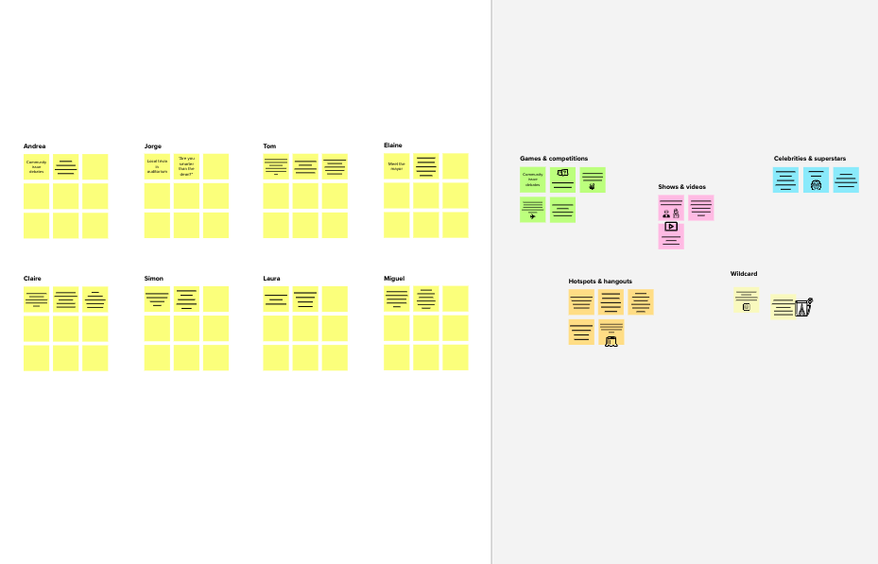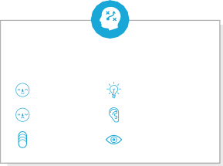

**Template**

#### Need some inspiration?

See a finished version of this template to kickstart your work.

[**Open example**](https://app.mural.co/template/e5a93b7b-49f2-48c9-afd7-a635d860eba6/93f1b98d-b2d2-4695-8e85-7e9c0d2fd9b9)

|  |  |  |  |  |
| --- | --- | --- | --- | --- |
|  |  |  |  |  |
|  |  |  |  |  |